1. Introduction

1.1 Project Background
The Guangdong-Hong Kong-Macao Greater Bay Area economy is growing rapidly, and the number of cross-boundary private cars is increasing. Currently, cross-boundary private car insurance applications rely on paper processes. Car owners must fill out multiple forms, submit numerous documents, and wait for approvals from various departments. Information cannot be shared effectively between insurance companies, traffic departments, and car owners. This results in slow processing, frequent errors, and user dissatisfaction.
Current insurance application issues:
- Users must repeatedly fill in the same information
- Paper documents are easily lost or damaged
- Users cannot track application progress
- Approval process takes 7–10 days
- Systems across departments are disconnected; data is not shared
This project aims to develop a digital platform for cross-boundary private car insurance. The platform connects users, insurance companies, and management departments, enabling data sharing and automated processes. Users can submit applications online, track their progress, and receive digital insurance policies — greatly improving efficiency and user experience.

1.2 System Objectives

1.2.1 Business Objectives
- Digitize the cross-boundary private car insurance application process
- Build a platform for information sharing
- Standardize application and approval procedures
- Provide data analysis capabilities

1.2.2 User Objectives
- Simplify the application process by reducing forms and documents
- Provide application progress tracking
- Support online payment
- Generate digital insurance policies
- Offer policy management and renewal reminders

1.2.3 Quantitative Indicators
- Reduce processing time from 7–10 days to 1–2 days
- Keep document error rate below 5%
- Achieve user satisfaction rate above 85%

1.3 Implementation Scope

1.3.1 System Boundary
The system covers the entire process from user registration to insurance policy delivery. It includes user management, vehicle information management, insurance product selection, online application, approval, payment, and policy management.

1.3.2 Functional Scope
Based on system design, there are six main functional modules:
- Product Selection Module: Allows users to browse and select cross-boundary insurance products
- Vehicle Management Module: Manages vehicle information and related policies
- Personal/Company Information Management Module: Handles user personal or business data
- Policy Management Module: Enables users to view and manage valid insurance policies
- Order Management Module: Manages insurance orders and payment records
- Claims Guide Module: Provides guidance on the claims process and required materials

1.3.3 Out of Scope Functions
- No vehicle accident claims processing
- No vehicle repair or maintenance services
- No regular (non-cross-boundary) vehicle insurance
- No freight vehicle insurance
- Mobile application not included in this phase (web version only)
This project will first be implemented in the Guangdong-Hong Kong-Macao Greater Bay Area, with potential for expansion to other cross-boundary regions. The system adopts a modular design to support future feature upgrades.

2. system architecture(加一下上云端的内容)

2.1 System High Level Overview
The system is designed using a three-tier architecture, which achieves modularity and maintainability through the separation of duties：
- Presentation Layer: The system uses Bootstrap framework to build a responsive user interface, including homepage, product page, personal centre and administration backend modules to provide users with an intuitive and simple operating experience.
- Business Logic Layers: The system contains core functional modules such as product management, quote calculation, policy processing and order management, each of which is encapsulated through a separate PHP file to ensure clear and maintainable business logic.
- Data Access Layers: The system uses PDO to connect to the MySQL database, which enables secure access to data such as users, products, quotes, policies, vehicles, etc. through unified database configuration and connection management.
Communication between the various layers of the system is carried out through standard interfaces. For example, after a user selects a product in the front-end, the business layer calls the corresponding calculation module to generate a quotation and then persists the result in the database. The whole system adopts modular design to ensure system security through unified user authentication and authority control mechanism, while reserving enough expansion space to provide a basis for future function enhancement and architecture optimisation. This layered architecture not only ensures a clear system structure, but also facilitates teamwork and later maintenance, while providing a good foundation for system performance optimization and functional expansion.

2.2 Main Modules

Presentation Layer
[Home] [Products] [Customer] [Admin]
- index.php (Main Page) - home.php (Personal Center)
- login.php (Login)
- register.php (Registration) - admin.php (Admin Panel) - pages/ (Page Components) - css/ (Style Files) - images/ (Image Resources)

↓

│ (RESTful API/JSON)

│
Business Logic Layer
1. User Management Module - User Authentication & Authorization
- User Information Management
- Session Management
2. Product Management Module - Product Information Management - Product Category Management - Product Pricing Rules
3. Policy Management Module - Policy Creation & Modification - Policy Status Management - Policy Query & Statistics
4. Payment Management Module - Payment Processing
- Order Management - Transaction Records

↓

│ (PDO/SQL)

│
Data Access Layer
1. Database Connection Management
- db_config.php (DB Configuration) - PDO Connection Pool
2. Data Operation Layer - User Data Operations
- Product Data Operations
- Policy Data Operations
- Order Data Operations
3. Cache Management - Data Caching - Session Caching

↓

│ (MySQL)

│

Database
1. User Table (user) - User_ID - User_name - Other User Information
2. Product Table (product) - Basic Product Information
- Product Category Information
3. Policy Table (policy) - Basic Policy Information
- Policy Status Information
4. Order Table (orders) - Order Information - Payment Information

2.3 Functions of main modules
In this cross-border vehicle insurance management system, components interact through various hierarchies:
- Users through the performance layer of the various interfaces (such as the home page, product pages, personal centre and management back-office) to initiate the request, these requests are sent to the business logic layer through AJAX in JSON format.
- Administrators enter the administration back office via admin.php and have access to functions such as user management, policy validation and data analysis.
- Business logic layer calls the corresponding processing modules according to the type of request (product selection, quote calculation, policy processing or order processing), which establishes a database connection through the db_config.php in the data access layer and processes the data by using the general function functions in functions.php.
- Data access layer performs SQL operations through PDO, interacts with various tables in the database (user table, product table, policy table, vehicle table, etc.), and returns the results to the user interface along the original path after processing.

3. Modules Description

3.1 User Module

3.1.1 User login module
The user login module is responsible for user authentication and data security. After users log in, they can enter their own personal center and access their own platform data. At the same time, it provides a comprehensive password management function to ensure the security of user accounts. The main functions include:
- User login
- User Registration
- The password is reset
- Username and password authentication
- Security verification code verification
- Abnormal login detection
- Indicates the password hash encryption

3.1.2 Quote and product module
This module provides users with insurance product information and quotation services. This module helps users choose the most suitable insurance products by calculating the recommended quotation of products. Specific functions include:
- Product information display and intelligent recommendation (According to user needs, historical data and risk appetite)
- Offer and discount calculation
- Quote view and details display
- Insurance terms and conditions and insurance confirmation

3.1.3 Payment module
The payment module provides secure and convenient payment services, supports multiple payment methods, and ensures the security and reliability of the transaction process. The main functions include:
- Payment processing (credit card payment, Alipay Pay, wechat Pay) and security verification
- Trading status updates
- Payment history query
- Download electronic invoice and generate proof of payment

3.1.4 Customer service module
This module provides customer support, including functions such as personal information management, user vehicle management and claims services. Specific services include:
- Party Management
- Basic information management
- Certificate information management
- Car Management
- Car basic information management
- Car certificate management
- Owner information management
- Order Management
- Check the application status (Approve/Reject/Waiting)
- Check the rejection reason email and reapply
- Claims service
- Claim application
- Progress query
- Claims Settlement Guide
- Historical claims records
- Policy Management
- Historical insurance record
- History of renewal
- History of surrender

3.2 Admin Module

4. Implementation Details
The cross-border insurance solution system was developed and deployed using modern technical architecture and rigorous project management processes, ensuring competitive functionality, security, and user experience compared to similar industry systems.

4.1 Technical Architecture Design

The system employs a layered architecture design. The backend is built using PHP 8.3.8 with native PHP development, ensuring efficient business logic processing and reliable data interactions. The frontend features responsive design incorporating HTML5, CSS3, and JavaScript, enhanced by the Bootstrap 5.1.3 framework for optimal layout adaptation and Font Awesome 6.0.0 icon library for improved visual presentation.

For database management, MariaDB 10.6.19 was selected with InnoDB storage engine to support high-concurrency transactions. The carefully designed table structure ensures query efficiency while effectively avoiding compatibility issues present in MySQL 5.7 (lack of Common Table Expressions(CTE) support) and MySQL 8.0 (character set incompatibilities).

(Figure 4.1 Development and Implementation Environment)
 | Development | Implementation
System | XAMPP 8.2.4 | CentOS 7.9
Apache | Apache 2.4.56 | Apache 2.4.6
Database | MariaDB 10.4.28 | MariaDB 10.6.19
PHP | PHP 8.2.4 | PHP 8.3.8

4.2 Core Technical Implementation

The system employs multiple optimization strategies to enhance performance and security. For database operations, the system employs multiple optimization strategies to enhance performance and security. For database operations, we optimized query efficiency through thoughtful table structure design and SQL query refinements.

The file processing module incorporates rigorous security protocols, including file type validation and size restrictions, to effectively mitigate risks associated with malicious file uploads.

For comprehensive data protection, the system implements multiple security measures:
-Sensitive information storage using HASH encryption
-Prepared statements to prevent SQL injection vulnerabilities
-Output encoding to guard against XSS attacks

These security implementations ensure full compliance with data protection requirements for cross-border operations while maintaining system stability and performance. The technical approach balances robust security with operational efficiency through carefully selected encryption and validation methods.

4.3 Cloud Deployment Architecture

The system supports flexible cloud deployment solutions, and can be based on platforms such as AWS, Azure or AliCloud to build a highly available architecture. Typical deployment topology includes CDN acceleration layer, elastic load balancer, and file persistence with object storage service. The monitoring system integrates the monitoring tools provided by cloud service providers and the data analysis module built independently to achieve comprehensive observation of infrastructure, application performance and business indicators. This architecture can support the high concurrency processing capability of the system and ensure that the API response latency is controlled within a reasonable range and the failure recovery time is shorter than the expected target.

4.4 System Environment Configuration

The system deployment environment covers the comprehensive configuration requirements of server-side and client-side. The server is recommended to use Windows Server or Linux operating system, with Apache as the Web server, and ensure that PHP 8.0 + operating environment. The database server should be configured with MariaDB 10.2.2+, and it is recommended to use master-slave replication architecture to enhance data availability. In terms of hardware, the server should be equipped with at least 2-core 2-thread CPU, 16GB RAM and 500GB SSD storage, and deployed in a network environment with a bandwidth of 100Mbps or above. Client support covers mainstream modern browsers, including Chrome, Firefox, Safari and Edge, and is optimised for resolutions ranging from 1920x1080 to 3840×2160 to ensure a consistent cross-platform user experience.

4.5 Implementation Milestones

The project implementation follows the traditional development methodology and completes the whole process from requirement analysis to formal go-live. The requirement analysis and planning phase focuses on business requirement specifications and lays the foundation for technical solutions. During the system development phase, the core functions of policy management, user authentication, data analysis and other front and back office functions are gradually implemented through iteration, during which test feedback is continuously collected to optimize the functional design. The system integration and testing phase focuses on completing functional testing and performance tuning. The final deployment phase adopts a prudent go-live strategy to ensure stable system operation.

4.6 Cloud Deployment Test Practice

The system was tested for basic deployment on the Aliyun platform with the following simple architecture:

(Figure 4.2 cloud deployment architecture)
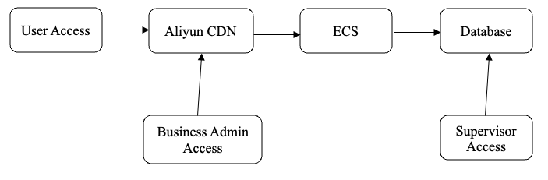
4.6.1 Specific deployment configurations:

4.6.1.1 Computing resources
- Use AliCloud ECS instances, configured as 2-core 2G
- Operating system: CentOS 7.9
- Web server: Apache 2.4.6 + PHP 8.3.8
- Database: MariaDB 10.6.19 deployed directly on ECS.
- Deployment region: Shenzhen region (taking into account cross-border business needs)

4.6.1.2 Database service
- MariaDB Direct Deployment on ECS Server
- Configure basic security policy
- Regular manual data backup to ECS local storage

4.6.1.3 Network and security:
- Accelerating static resources using Aliyun free CDNs
- Configure basic security group rules
- Use free SSL certificates

4.6.2 Test results:

4.6.2.1 Performance test:
- System response time: 300ms on average
- Concurrent processing capability: support 50+ users online at the same time
- File upload and download: basically meets the demand
- Database query response: 100ms on average

4.6.2.2 Stability test:
- Stable system operation
- No data loss when manually backing up data to ECS locally.
- Basic monitoring and alarm function is normal

4.6.2.3 Cost-effectiveness:
- Average monthly running cost: about 50 RMB
- Resource utilisation: CPU 30% on average, memory 50% on average
- Resource utilisation: CPU 30%, memory 50% on average, storage utilisation: about 40%.

4.6.2.4 user experience:
- Page load time: 2 seconds on average
- System availability: basically meets requirements

4.7 Performance and outcomes

The cloud deployment has demonstrated strong operational readiness, with the system handling core business processes reliably in production. The architecture delivers solid performance for cross-border insurance transactions, with CDN integration noticeably improving static content delivery. System responsiveness meets service level expectations, while monitoring and security controls maintain stability.

Looking at the broader deployment model, three key areas should be focussed on:

- Resource management - potentially through dedicated compute allocation, separating database and application workloads to avoid resource contention
- Data protection - establishing automated backup workflows to back up data to OSS with appropriate retention policies and recovery validation
- Growth readiness - planning for capacity expansion through caching layers and database scaling options

5. Database Design
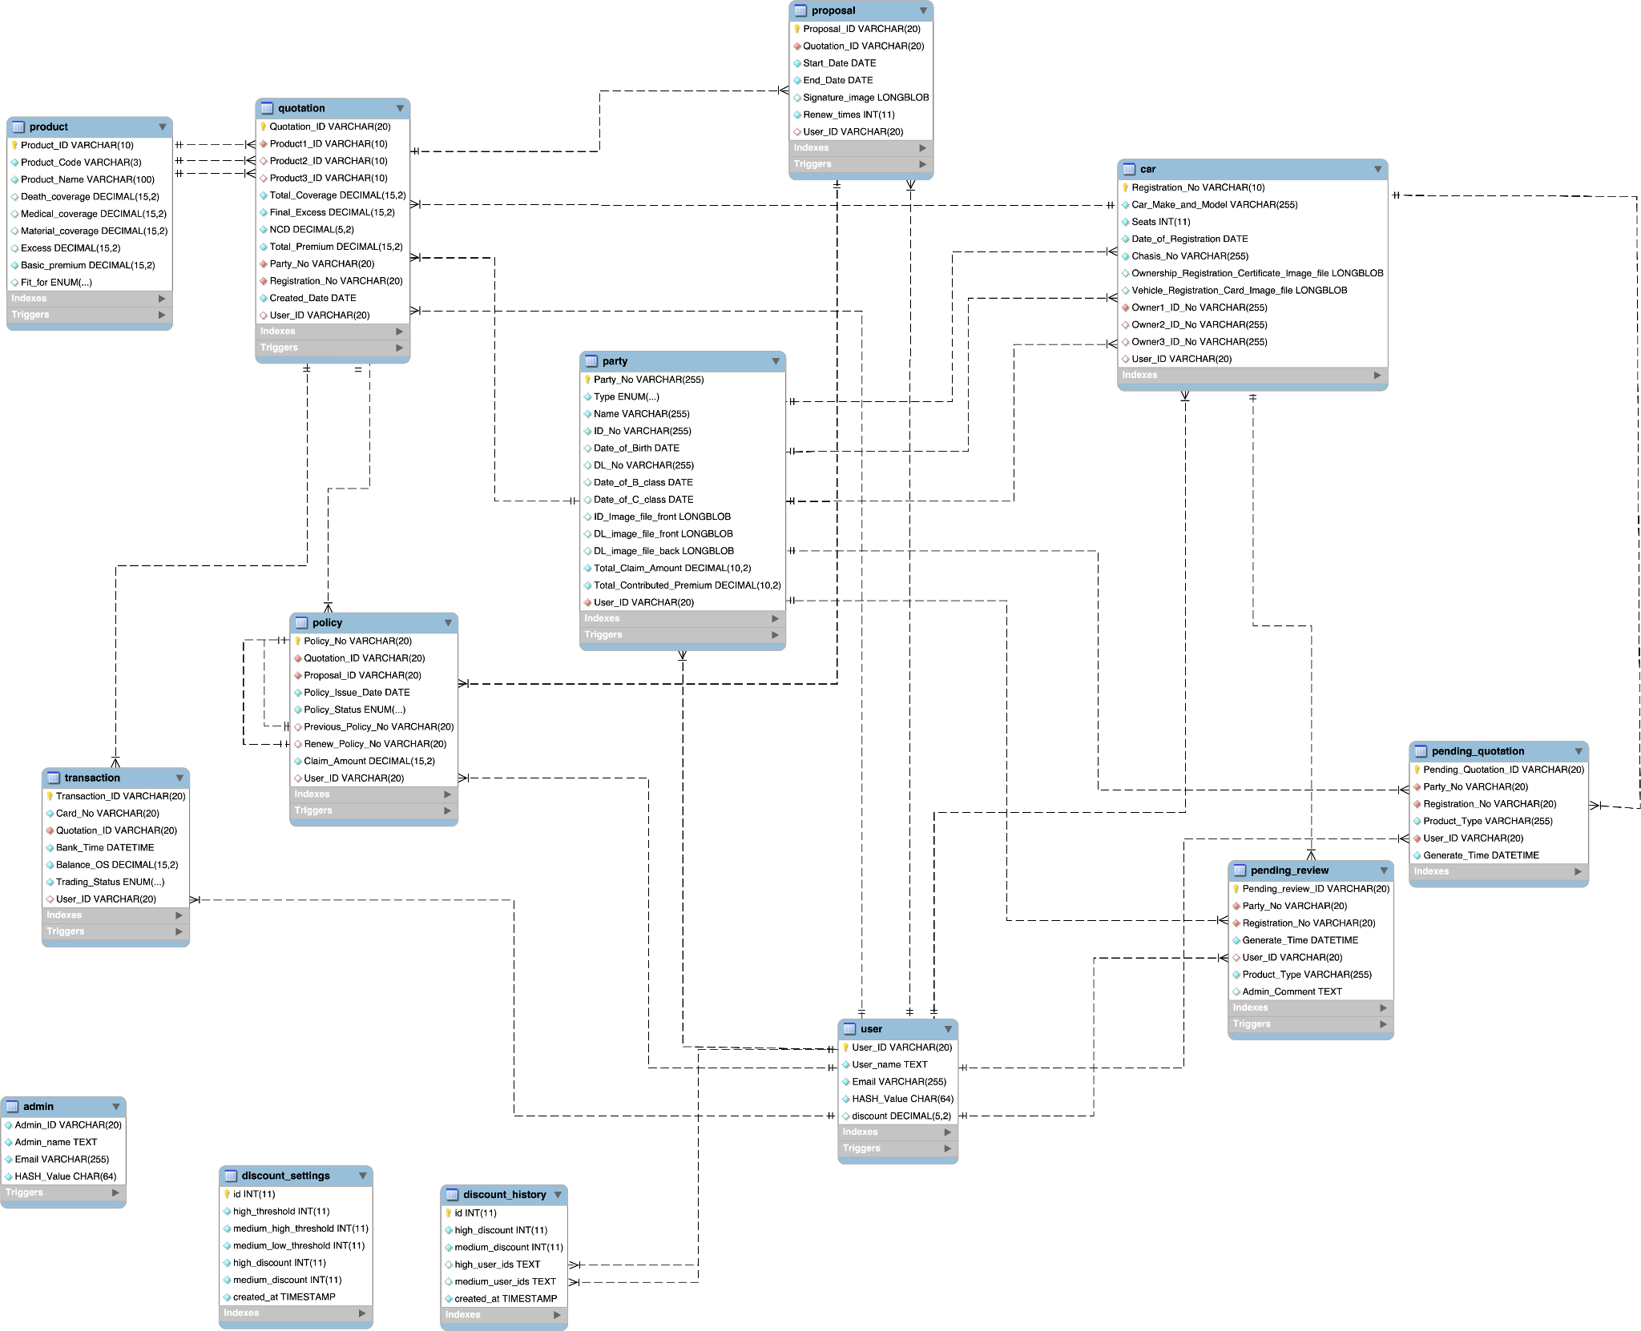

admin
Column | Type | Null | Default | Links to | Comments | Media type
Admin_ID | varchar(20) | No
Admin_name | text | No
Email | varchar(255) | No
HASH_Value | char(64) | No
No index defined!

car
Column | Type | Null | Default | Links to | Comments | Media type
Registration_No (Primary) | varchar(10) | No
Car_Make_and_Model | varchar(255) | No
Seats | int(11) | No
Date_of_Registration | date | No
Chasis_No | varchar(255) | No
Ownership_Registration_Certificate_Image_file | longblob | Yes | NULL
Vehicle_Registration_Card_Image_file | longblob | Yes | NULL
Owner1_ID_No | varchar(255) | No |  | party -> Party_No
Owner2_ID_No | varchar(255) | Yes | NULL | party -> Party_No
Owner3_ID_No | varchar(255) | Yes | NULL | party -> Party_No
User_ID | varchar(20) | Yes | NULL | user -> User_ID

Indexes
Keyname | Type | Unique | Packed | Column | Cardinality | Collation | Null | Comment
PRIMARY | BTREE | Yes | No | Registration_No | 23 | A | No
idx_car_user_id | BTREE | No | No | User_ID | 23 | A | Yes
fk_owner1 | BTREE | No | No | Owner1_ID_No | 23 | A | No
fk_owner2 | BTREE | No | No | Owner2_ID_No | 23 | A | Yes
fk_owner3_party_no | BTREE | No | No | Owner3_ID_No | 11 | A | Yes

discount_history
Column | Type | Null | Default | Links to | Comments | Media type
id (Primary) | int(11) | No
high_discount | int(11) | No
medium_discount | int(11) | No
high_user_ids | text | Yes | NULL
medium_user_ids | text | Yes | NULL
created_at | timestamp | No | current_timestamp()

Indexes
Keyname | Type | Unique | Packed | Column | Cardinality | Collation | Null | Comment
PRIMARY | BTREE | Yes | No | id | 0 | A | No

discount_settings
Column | Type | Null | Default | Links to | Comments | Media type
id (Primary) | int(11) | No
high_threshold | int(11) | No
medium_high_threshold | int(11) | No
medium_low_threshold | int(11) | No
high_discount | int(11) | No
medium_discount | int(11) | No
created_at | timestamp | No | current_timestamp()

Indexes
Keyname | Type | Unique | Packed | Column | Cardinality | Collation | Null | Comment
PRIMARY | BTREE | Yes | No | id | 5 | A | No

party
Column | Type | Null | Default | Links to | Comments | Media type
Party_No (Primary) | varchar(255) | No
Type | enum('Individual', 'Company') | No
Name | varchar(255) | No
ID_No | varchar(255) | No
Date_of_Birth | date | Yes | NULL
DL_No | varchar(255) | Yes | NULL
Date_of_B_class | date | Yes | NULL
Date_of_C_class | date | Yes | NULL
ID_Image_file_front | longblob | Yes | NULL
DL_image_file_front | longblob | Yes | NULL
DL_image_file_back | longblob | Yes | NULL
Total_Claim_Amount | decimal(10,2) | No
Total_Contributed_Premium | decimal(10,2) | No
User_ID | varchar(20) | No |  | user -> User_ID

Indexes
Keyname | Type | Unique | Packed | Column | Cardinality | Collation | Null | Comment
PRIMARY | BTREE | Yes | No | Party_No | 69 | A | No
fk_party_user | BTREE | No | No | User_ID | 17 | A | No

pending_quotation
Column | Type | Null | Default | Links to | Comments | Media type
Pending_Quotation_ID (Primary) | varchar(20) | No
Party_No | varchar(20) | No |  | party -> Party_No
Registration_No | varchar(20) | No |  | car -> Registration_No
Product_Type | varchar(255) | No
User_ID | varchar(20) | No |  | user -> User_ID
Generate_Time | datetime | No

Indexes
Keyname | Type | Unique | Packed | Column | Cardinality | Collation | Null | Comment
PRIMARY | BTREE | Yes | No | Pending_Quotation_ID | 6 | A | No
idx_party_no | BTREE | No | No | Party_No | 6 | A | No
idx_registration_no | BTREE | No | No | Registration_No | 6 | A | No
idx_user_id | BTREE | No | No | User_ID | 6 | A | No

pending_review
Column | Type | Null | Default | Links to | Comments | Media type
Pending_review_ID (Primary) | varchar(20) | No
Party_No | varchar(20) | No |  | party -> Party_No
Registration_No | varchar(20) | No |  | car -> Registration_No
Generate_Time | datetime | No
User_ID | varchar(20) | Yes | NULL | user -> User_ID
Product_Type | varchar(255) | No
Admin_Comment | text | Yes | NULL

Indexes
Keyname | Type | Unique | Packed | Column | Cardinality | Collation | Null | Comment
PRIMARY | BTREE | Yes | No | Pending_review_ID | 37 | A | No
fk_review_party_no | BTREE | No | No | Party_No | 12 | A | No
fk_review_registration_no | BTREE | No | No | Registration_No | 18 | A | No
idx_pending_review_user_id | BTREE | No | No | User_ID | 4 | A | Yes

policy
Column | Type | Null | Default | Links to | Comments | Media type
Policy_No (Primary) | varchar(20) | No
Quotation_ID | varchar(20) | No |  | quotation -> Quotation_ID
Proposal_ID | varchar(20) | No |  | proposal -> Proposal_ID
Policy_Issue_Date | date | No
Policy_Status | enum('Expired', 'Renewed', 'Inforce', 'Waiting', 'Cancel') | No
Previous_Policy_No | varchar(20) | Yes | NULL | policy -> Policy_No
Renew_Policy_No | varchar(20) | Yes | NULL | policy -> Policy_No
Claim_Amount | decimal(15,2) | No | 0.00
User_ID | varchar(20) | Yes | NULL | user -> User_ID

Indexes
Keyname | Type | Unique | Packed | Column | Cardinality | Collation | Null | Comment
PRIMARY | BTREE | Yes | No | Policy_No | 58 | A | No
fk_policy_proposal_id | BTREE | No | No | Proposal_ID | 58 | A | No
fk_policy_previous_policy_no | BTREE | No | No | Previous_Policy_No | 14 | A | Yes
fk_policy_renew_policy_no | BTREE | No | No | Renew_Policy_No | 4 | A | Yes
fk_policy_quotation_id | BTREE | No | No | Quotation_ID | 58 | A | No
idx_policy_user_id | BTREE | No | No | User_ID | 19 | A | Yes

product
Column | Type | Null | Default | Links to | Comments | Media type
Product_ID (Primary) | varchar(10) | No
Product_Code | varchar(3) | No
Product_Name | varchar(100) | No
Death_coverage | decimal(15,2) | Yes | NULL
Medical_coverage | decimal(15,2) | Yes | NULL
Material_coverage | decimal(15,2) | Yes | NULL
Excess | decimal(15,2) | Yes | NULL
Basic_premium | decimal(15,2) | No
Fit_for | enum('Less_than_5_seats', 'Over_5_seats', 'All') | Yes | NULL

Indexes
Keyname | Type | Unique | Packed | Column | Cardinality | Collation | Null | Comment
PRIMARY | BTREE | Yes | No | Product_ID | 17 | A | No

proposal
Column | Type | Null | Default | Links to | Comments | Media type
Proposal_ID (Primary) | varchar(20) | No
Quotation_ID | varchar(20) | No |  | quotation -> Quotation_ID
Start_Date | date | No
End_Date | date | No
Signature_image | longblob | Yes | NULL
Renew_times | int(11) | No | 0
User_ID | varchar(20) | Yes | NULL | user -> User_ID

Indexes
Keyname | Type | Unique | Packed | Column | Cardinality | Collation | Null | Comment
PRIMARY | BTREE | Yes | No | Proposal_ID | 110 | A | No
fk_proposal_quotation_id | BTREE | No | No | Quotation_ID | 110 | A | No
idx_proposal_user_id | BTREE | No | No | User_ID | 18 | A | Yes

quotation
Column | Type | Null | Default | Links to | Comments | Media type
Quotation_ID (Primary) | varchar(20) | No
Product1_ID | varchar(10) | No |  | product -> Product_ID
Product2_ID | varchar(10) | Yes | NULL | product -> Product_ID
Product3_ID | varchar(10) | Yes | NULL | product -> Product_ID
Total_Coverage | decimal(15,2) | No
Final_Excess | decimal(15,2) | No
NCD | decimal(5,2) | No
Total_Premium | decimal(15,2) | No
Party_No | varchar(20) | No |  | party -> Party_No
Registration_No | varchar(20) | No |  | car -> Registration_No
Created_Date | date | No
User_ID | varchar(20) | Yes | NULL | user -> User_ID

Indexes
Keyname | Type | Unique | Packed | Column | Cardinality | Collation | Null | Comment
PRIMARY | BTREE | Yes | No | Quotation_ID | 119 | A | No
idx_product1_id | BTREE | No | No | Product1_ID | 39 | A | No
idx_product2_id | BTREE | No | No | Product2_ID | 39 | A | Yes
idx_product3_id | BTREE | No | No | Product3_ID | 29 | A | Yes
idx_party_no | BTREE | No | No | Party_No | 119 | A | No
idx_registration_no | BTREE | No | No | Registration_No | 59 | A | No
idx_quotation_user_id | BTREE | No | No | User_ID | 19 | A | Yes

transaction
Column | Type | Null | Default | Links to | Comments | Media type
Transaction_ID (Primary) | varchar(20) | No
Card_No | varchar(20) | No
Quotation_ID | varchar(20) | No |  | quotation -> Quotation_ID
Bank_Time | datetime | No
Balance_OS | decimal(15,2) | No
Trading_Status | enum('Written_off', 'Unwritten_off') | No
User_ID | varchar(20) | Yes | NULL | user -> User_ID

Indexes
Keyname | Type | Unique | Packed | Column | Cardinality | Collation | Null | Comment
PRIMARY | BTREE | Yes | No | Transaction_ID | 31 | A | No
fk_transaction_quotation_id | BTREE | No | No | Quotation_ID | 31 | A | No
idx_transaction_user_id | BTREE | No | No | User_ID | 10 | A | Yes

user
Column | Type | Null | Default | Links to | Comments | Media type
User_ID (Primary) | varchar(20) | No
User_name | text | No
Email | varchar(255) | No
HASH_Value | char(64) | No
discount | decimal(5,2) | Yes | 0.00

Indexes
Keyname | Type | Unique | Packed | Column | Cardinality | Collation | Null | Comment
PRIMARY | BTREE | Yes | No | User_ID | 9 | A | No
Email | BTREE | Yes | No | Email | 9 | A | No

6. System evaluation

6.1 Limitations of implementation

6.1.1. Limitations in Data Integration and Sharing
The system faces data integration challenges. It needs to connect with different databases from insurers and traffic departments, but they use different formats for license plates and policy IDs. This requires extra programming to standardize the data, making development more complex.
Another issue is data timeliness. Our platform needs real-time updates, but traffic departments only provide daily batch updates about vehicle quotas. This delay could cause problems, so we may need to implement faster notification systems.

6.1.2. Bottlenecks in Process Automation
The system's automation has some limitations. First, when users upload ID documents like travel permits or driver's licenses, the photos might be unclear or have reflections. This makes the computer's text recognition less accurate, sometimes below 95%, so staff still need to check manually. This means we can't have completely automatic applications yet.
Another problem is with the approval process. We want approvals to take just 1-2 days, but sometimes different departments need to check information manually. For example, Hong Kong insurance companies might need to verify details about mainland vehicles themselves. When this happens, we should have a special process to handle these exceptions and record why manual checking was needed.

6.1.3. Risks in System Performance and Scalability
The system may struggle during busy times like holidays when many people apply at once. If over 500 users submit applications simultaneously and the database isn't properly set up, the system could slow down or stop responding.
Also, while the system is designed to be flexible, adding support for new regions like Shenzhen-Hong Kong would need extra checks. We'd have to make sure the policy management features can handle different local rules, such as Hong Kong's required third-party insurance coverage.

6.1.4. User Experience and Functional Gaps
The current system only shows basic status updates like "Informed ". Users want more detailed information, such as when their application is being reviewed by the traffic department or when their premium is being calculated. We should add these sub-statuses and send notifications via text or WeChat.
The platform only works on computers, which isn't convenient for phone users. As a temporary solution, we could create a mobile-friendly website that works offline. This would help until we can develop a proper mobile app.

6.2. Future Improvement
1. Data Integration:
- Create a unified data platform to automatically convert formats between different departments
- Use blockchain to securely record important transactions

2. Process Improvements:
- Automatically fill 80% of application forms using existing data
- Set up rules to auto-approve simple cases (like vehicles under 5 years old with no claims)

3. Security & Compliance:
- Build automatic checks for regional regulations
- Flag suspicious applications (like multiple submissions from same IP) for review

7. Project Schedule and Job Division

7.1 Project Schedule

Proposal Project Schedule Gantt Chart:

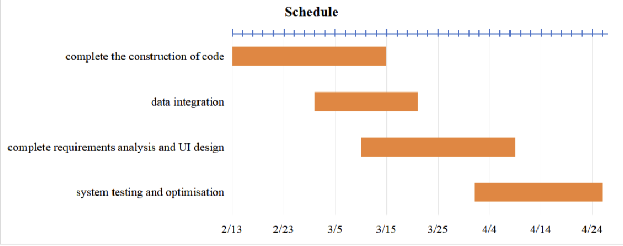

Actual Project Schedule Gantt Chart:

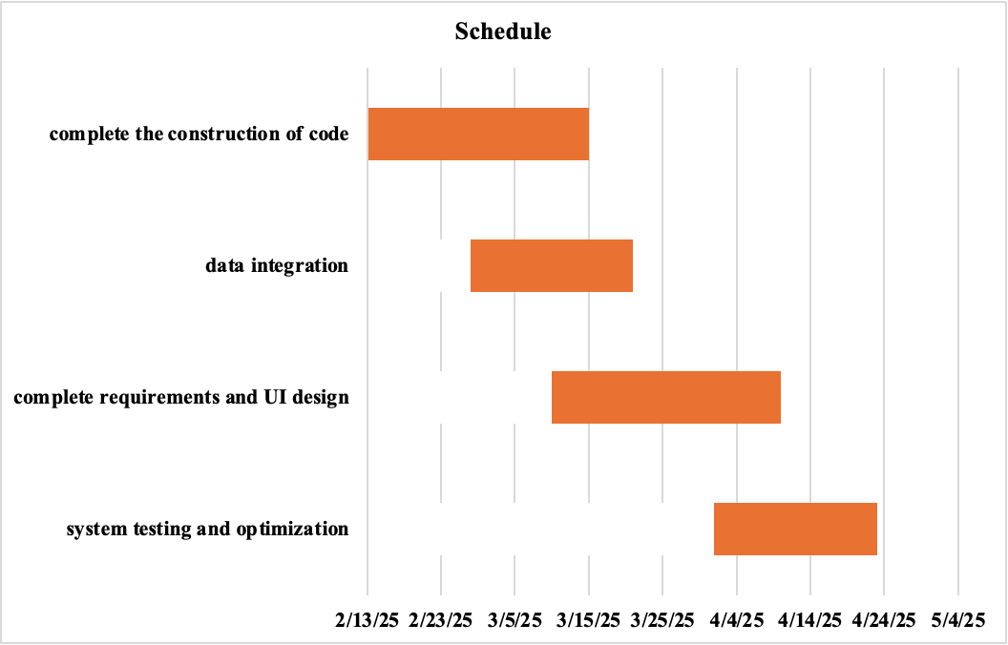
The comparison between the proposal and actual Gantt charts shows that while the overall project was completed on time, some phases experienced minor schedule deviations.

7.2 Job Division
QU YUMING Macro | - Manage overall project timeline and task allocation  - Oversee coordination between frontend, backend, and UI design  - Prepare DFDs with group members  - Maintain data dictionary and data store structures  - Collaborate with backend on defining database schema  - Integrate frontend with backend APIs  - Maintain project documentation and version control
HO CHANHOU Alvin | - Design user interface layouts for web pages (user, admin portals)  - Create wireframes, mockups, and style guides  - Ensure designs are responsive and accessible  - Provide tooltip content and field input examples  - Collaborate with frontend developer for UI implementation  - Update designs based on testing and feedback
WANG TSZ CHING Phoebe | - Develop frontend components: registration, policy application, dashboard  - Implement client-side form validation and document upload features  - Optimize UI responsiveness across devices  - Conduct frontend testing and fix UI bugs  - Support UI/UX improvements  - Draft sections for proposal and final report, including problem statement and scope
ZHAN ZIYUE Moon | - Design data flow diagrams and system logic charts  - Handle system integration and testing planning  - Review all deliverables for consistency and completeness  - Help prepare technical documentation and testing procedures  - Assist in system testing and debugging
CHEN RUOHAN Dorothy | - Conduct business analysis of the current cross-boundary insurance process  - Define functional and non-functional requirements in detail  - Map out user flows, system use cases, and stakeholder interactions  - Design validation rules for insurance forms (e.g., required fields, format checks)  - Assist with system testing and user feedback collection
ZHANG XIZHE Terrence | - Build backend logic for user accounts, insurance applications, and admin controls  - Design and implement secure database schema  - Develop APIs for frontend interaction (e.g., policy submission, status checks)  - Implement data encryption and access control  - Conduct performance testing and database optimization  - Set up logging, backups, and basic disaster recovery procedures

